Registration
It is mandatory for the Author/Authors (at least one) of all accepted papers to be present at the SRS 2018 on the given date for presenting the paper. This can be confirmed by registering.

Contact details
For all communication regarding SRS 2018
Academic Affairs/Planning & Research Division
Sri Lanka Institute of Advanced Technological Institute – SLIATE
No: 320, T.B.Jayah Mawatha
Colombo 10
Tel: 0112 691 631 (Direct) 104 (Extension)
0112696804
E-mail: ddgaapr@sliste.ac.lk

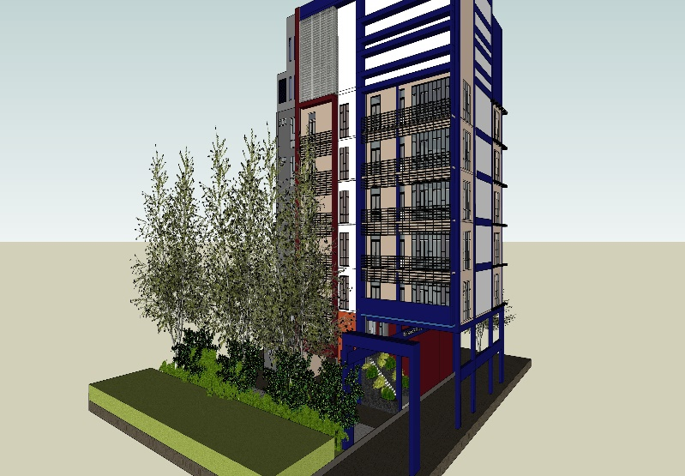
Academic Affairs / Planning & Research Branch (AA/PR)

Academic Affairs / Planning & Research Division coming under the purview of Director General - SLIATE. Dr. W. Hilary E. Silva is mandated to organize research symposium annually. This is the 2nd symposium of SLIATE.
Objectives of this symposium are:
- To provide opportunities to our academics to add values to their research and teaching activities.
- To provide a forum for exchanging interactive views among SLIATE’s academics and outsiders.
- To inculcate research culture among SLIATE’s academics.
This year, this symposium is extended to outsiders as well in addition to our academics.
Chair-SRS 2018
Dr.W.Hilary E.Silva
Director General,
No: 320, T. B. Jayah Mawatha
Colombo 10.
Tel: 0112 691 631
E-mail: dg@sliste.ac.lk

Co-Chair-SRS 2018
Deputy Director General (AA/ PR)
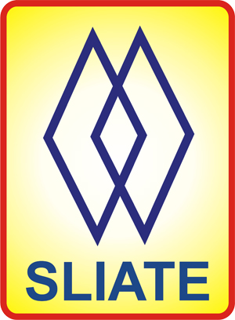Sri Lanka Institute of Advanced Technological Education (SLIATE)

SLIATE RESEARCH SYMPOSIUM 2018
(SRS 2018)
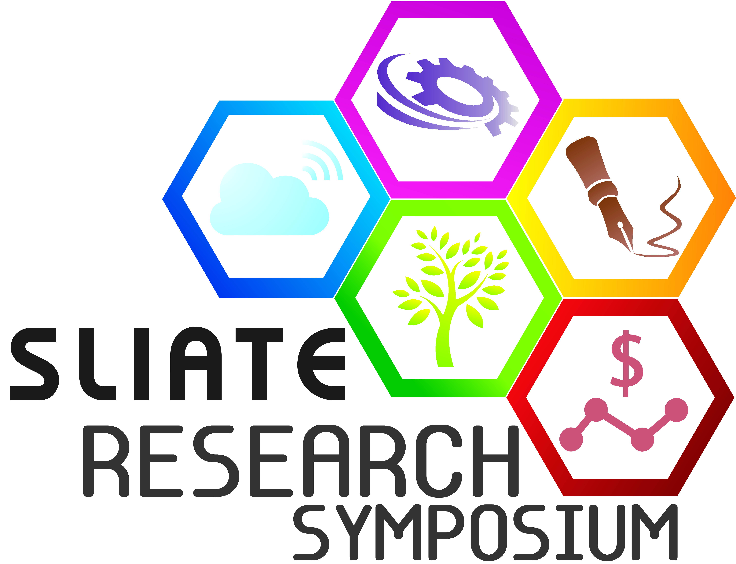

Professional Progress for Social Sustainability
October 2018

Call for Papers – SRS 2018

Sri Lanka Institute of Advanced Technological Education
Sri Lanka Institute of Advanced Technological Education (SLIATE) that was established under the provisions of the act of parliament no 29 of 1995 is currently functioning within the purview of Ministry of Higher Education and Cultural Affairs. SLIATE is one of the leading government institutions in the Alternative Higher Education Sector in Sri Lanka.
At present, SLIATE manages and supervises eleven Advanced Technological Institutes and eight Sections. It conducts a broad range of multi-disciplinary programs in English medium targeting at students who have passed A/L examination in Sri Lanka. They are: Higher National Diploma in Accountancy, Agriculture, Business Administration, Business Finance, Building Services Engineering, Consumer Sciences and Product Technology, Engineering(Civil, Electrical & Electronic, Mechanical), English, Food Technology, Information Technology, Management, Project Management, Quantity Surveying and Tourism & Hospitality Management.
As a step further, last year SLIATE provided opportunities to its academics to involve in research activities also in addition to teaching and learning. This year, SLIATE has extended the opportunities to outsiders as well. This act has provided a common platform to SLIATE members to share their experience/new knowledge with their colleagues and outsiders.

Call for Papers
The Sri Lanka Institute of Advanced Technological Education (SLIATE) is pleased to call for technical papers from Academics of SLIATE and Researchers from Sri Lanka to be presented at the SLIATE RESEARCH SYMPOSIUM 2018 (SRS 2018), which will be held on 05th October 2018.
Important Dates
Calling full papers | 08th June 2018
Last date for submission of full paper | 08th August 2018
Notification of acceptance | 08th September 2018
Registration | 20th September 2018
Last date to submit corrected finalized full paper | 31st September 2018
Date for submission of presentation | 28th September 2018
Proposed dates for SRS 2018 | 05th October 2018
SRS 2018 provides a forum for Sri Lankan Academics, Researchers and Students of SLIATE to share their experience/new knowledge with their colleagues and outsiders. Full Papers are invited under the following categories: Business (Management, Accountancy, Tourism and Hospitality Management), Technology (Information Technology, Agriculture & Food Science, and Engineering), Humanities & social science (English, Law etc.) to be presented at the SRS 2018 and published in the proceedings of SRS 2018.

Accepting Full Paper
Full paper received on or before 08th August 2018 only will be considered for further processing. A review committee will be appointed consisting of eminent people from outside of SLIATE. Once full paper is accepted, it will be notified to the Author on or before 08th September 2018
Finalized Full Paper
Full paper will be scrutinized by the Editorial Board and will make modifications if necessary and informed to the Author. Finalized full paper has to be submitted on or before 31st September 2018.
The authors are advised to submit the full paper in word format according to the given format. Please visit www.sliate.ac.lk for more information.

The decision of the Editorial Board on the acceptance/rejection of the Paper for publication shall be final.

